# Project Milestone & Activity Planning



**Team ID:** PNT2022TMID33764

**Team Name**: AI-based discourse for Banking Industry

# AI-based discourse for Banking Industry

* Artificial intelligence in the banking industry makes banks effective, reliable, helpful, and more understanding. This is the problem's answer. It is enhancing the modern banks' competitive edge in the age of digital technology. The banking industry is seeing an increasing impact of AI that reduces operational costs, enhances customer service, and automates processes. Nearly 40% to 50% of financial and banking service providers are using AI in their processes to harness the power of next-generation AI capabilities. The companies believe that AI is the future of banking sector which can perform a range of banking operations in faster, easier, and more secure ways.
* Banking using AI Chatbots assist clients in a variety of ways. One of the important applications of AI in the banking business is the usage of chatbots in the financial sector. AI chatbots in banking are revolutionizing how firms offer their clients services.
* In the banking sector, AI chatbots may assist consumers around-the-clock and provide thorough answers to their questions. Users receive a tailored experience from these chatbots.
* AI chatbots in banking are enhancing the client experience.
* Consequently, AI chatbots for banking and finance processes enable banks to increase brand recognition, improve customer service, and draw in more customers.

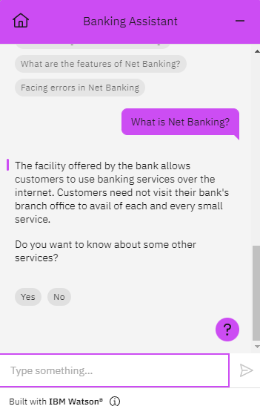

**Activity List:**

1. Create IBM Services.
2. Creating skills & Assistant for Chatbot.
3. Creating Savings account action.
4. Creating Current account action.
5. Creating Loan account action.
6. Creating a general query action.
7. Creating a Net banking action.
8. Create HTML web page.
9. Integrate the Watson Chatbot with web page.

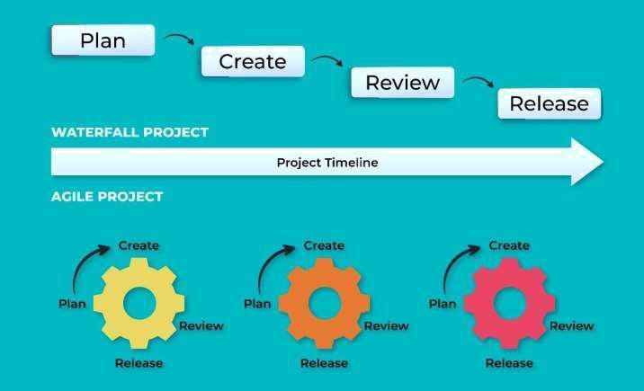

**Agile Methodology for Activity Planning**